

Cori Lowery Brotherton Nursing Scholarship

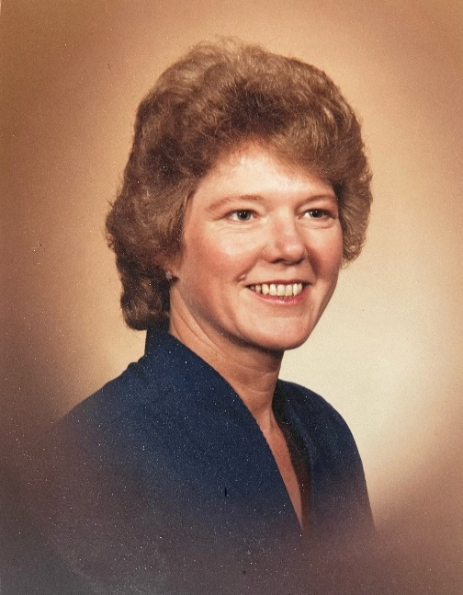
Coralie "Cori" Lowery Brotherton grew up in Silverton, Oregon and attended Good Samaritan School of Nursing in Portland, graduating on her twenty-first birthday in 1959 as a registered nurse. She then began her long dedicated nursing career at the Corvallis Clinic in Corvallis, Oregon. After working for many years as a nurse, Cori became one of the first Nurse Practitioners in Oregon in 1975. Cori was a much-loved and favorite provider at the Corvallis Clinic where she continued to practice until her retirement in 2001, serving more than 40 years in her beloved profession of nursing. In addition to her dedication to the nursing profession, Cori had an amazing positive attitude, giving spirit and work ethic. She looked at the world as one big adventure and had a compassionate and loving heart toward everyone she met.

Her other passions included baking, raising chickens, playing piano and gardening. Cori was a master gardener and could "make anything grow" so, it is in the spirit of growth that Cori's family wishes to celebrate her amazing life of love and dedication through the Cori Lowery Brotherton Nursing Scholarship.

Number of Awards: | Up to five* | Submission Deadline: | October 20, 2025
Amount of Award: | $1,000* | Recipients Notified: | November 2025
 |  | Awards Checks Mailed: | December 2025
* The committee anticipates granting five $1,000 one-time scholarships. However, scholarship award amounts may vary depending on applicant pool and financial need.

Eligibility
Candidates must meet the following criteria to apply:
- Current employee of Legacy Health.
- Accepted to/enrolled in a LPN, ADN, BSN, MA or CNA program.
- GPA of at least 3.0, if currently enrolled.
- Employees from all programs/departments are eligible and encouraged to apply.
- Demonstrate a commitment to the field of nursing and serving Legacy patients.



Cori Lowery Brotherton Nursing Scholarship

APPLICATION

Applicants must submit the following items for evaluation by the selection committee preferably via email to Kristine Krause, kkrause@lhs.org, or mail to Kristine Krause, Legacy Health Foundation, PO Box 4484, Portland, OR 97208, with the subject line “Cori Lowery Brotherton Nursing Scholarship”, received no later than 5pm on October 20, 2025:

- Personal Statement of Financial Status
- Short Answer Essay Questions
- College Transcript for GPA Review, if currently enrolled
- One Professional Reference Letter

Candidates must type their application using this form to be considered.
Name
Address
Street City State Zip
Phone Email
Hospital Site Department of Employment
Position Title Supervisor Name
Are you full time or part time? Please list your FTE status:
Length of employment with Legacy Health ___________________________________________
Last completed degree
Name of educational institution funds are requested for
Program Name Cumulative GPA (if currently enrolled)
University Mailing Address:
City, State, Zip:
Student ID #: Term Start Date:
When did/will you start this program?
When do you expect to complete your degree?

Personal Statement of Financial Status:
How many credit hours do you intend to take in the 2026 calendar year?
Tuition cost per credit hour: | x $
Expected total 2026 tuition cost: | $
Expected LEAP reimbursement for these terms: | - $
Other scholarships or tuition assistance expected? | - $
Remaining balance: | = $

Please provide a brief statement generalizing your financial status. Consider how you plan to finance your education. If applicable, include details about your family's financial situation such as the number of family members currently pursuing post-secondary education or other important considerations. Please indicate if you have received other financial aid or scholarships, and from what source.

Please provide short answers to each question in about 100 words or less.

  - How do your career goals and this degree further the mission of Legacy Health?

  - Why did you choose to work on this degree?

  - How would this scholarship assist you in obtaining your goals?

CERTIFICATION

I hereby certify that all the information provided in and with this application is true and accurate. Further, I certify that my own ideas and work product are set forth in this application.

Applicant’s Signature Date

Check List

□ Completed application – signed by applicant and dated.
□ Professional reference letter
□ Transcripts from Educational Institution, if currently enrolled.
Scholarship recipients will be notified in November 2025. Award checks will be mailed directly to the educational institution for tuition in December 2025.

